ARKANSAS JUNE 2012
OVERHEADS

SELECTED LESSONS FROM THE LIFE OF DAVID
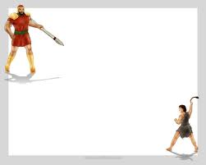

THE EPIC STRUGGLE OF DAVID AND GOLIATH

OUR GOD IS A GOD OF PROCESS
His Ways Are Higher Than Our Ways
David’s quiet years were similar to other worthies:
Joshua and Caleb sojourned for 40 years with Moses as their mentor.
Rahab the harlot saw Israel’s God from a far off in the harsh Gentile world.
Ruth and Naomi learned faith in their barren sojourn.
John the Baptist grew up in the wilderness of Judah.
Jesus grew up in the seamy village of Nazareth observing pathetic humanity and biding his time to “be about his father’s business.”

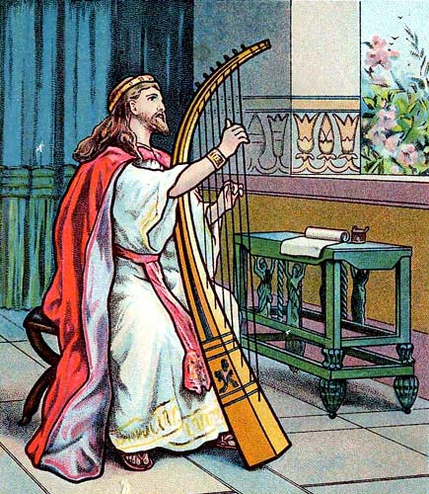
John 2v.24: “But Jesus did not trust himself unto them, because he knew all men, and needed not that any should testify of man, for he knew what was in man.”
Psalm 3:v.1 “Lord, how are they increased that trouble me!”
Psalm 5v.8:“Lead me, O Lord, in thy righteousness because of mine enemies; make the way straight…”
Psalm 12 v.8 “The wicked walk on every side, when the vilest men are exalted.”

3

DAVID LEARNED ABOUT MEN AND THEIR BEHAVIOR BY OBSERVATION IN SAUL’S COURT.

The Anakim were not totally destroyed by Joshua…
The Principle of Sin Management dictates that either we check Sin quickly or later when it has greatly magnified.
Goliath: Between 9 & 12 feet tall
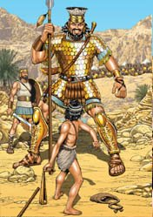

Th

4

ARMOR WEIGHED ABOUT 140 lbs.

SPEAR LIKE A WEAVER’S BEAM, THE SIZE OF A MAN’S WRIST.

BODY ARMOR WAS BRASS (FLESH MAGNIFIED)
SPEAR HEAD WEIGHED ABOUT 7 lbs.

4
Goliath’s terrible persona types Daniel’s 4th Beast. “dreadful and terrible and exceedingly strong.” AND a looming obstacle to God’s Nation and Kingdom in the Day of the Lord.
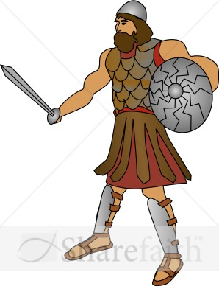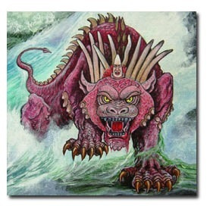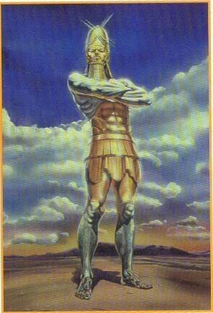

5.

GOLIATH IS A MID-DISPENSATIONAL GOGUE

5

I Samuel 17 v. 16: “And the Philistine drew near … and presented himself forty days.
40 is the number for probation, trial and chastisement. (Bullinger)
Products of 40 are significant 5(grace) and 8(renewal) = Life After Probation
4 (material completeness) and10 (divine order) =Enlarged Dominion & Extended Rule
6

6.

D

Forty years of grinding warfare and pestilence usher in a New World Order of Peace.

THERE IS A PLACE FOR RIGHTEOUS ANGER
I SAM. 17 V.26 “…who is this uncircumcised Philistine that he should defy the armies of the
living god?”

JOHN 2:17 “make not my Father’s house a house of merchandise….the zeal of my Father’s house hath eaten me up”.
7

FIVE SMOOTH STONES…the # of Grace, “washed by the water of the word.” And guided by angelic agent TO STRIKE Goliath’s forehead.
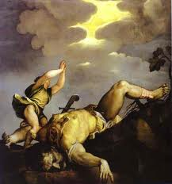
GO TO I Kings 22 v. 19-22: an example of immortal beings going forth from the throne of Yahweh doing His will as in Ezek 1 and Revelation Chapter 4 & 5.

8.

8.

IT’S ABOUT DOMINION:
Gen. 1v.28: “Be fruitful and multiply, and fill the earth and subdue it, and have dominion…” over now a cursed creation.
Man’s own sin nature and his alienation form Yahweh.over now a cursed humanity.
I Samuel 17v.51: “Therefore David ran, and stood upon the Philistine…and cut off his head.”… “he shall bruise thy head”
Heb. 2v.8: “Thou hast put all things in subjection under his feet…all in subjection under him, …nothing is not put under him, …now we see not yet all things put under him.” #4 Is Material Completeness!
9

VERSES WHERE DOMINION IS PROMISED
John 17 v.2: “thou hast given him power over all flesh”.
I Cor. 15v.27: “He hath put all things under his feet.”
Philippians 3v.21: “Subdue all things unto himself.”
I Pet. 3v.22: …”angels, and authorities and powers being made subject unto him.”

Rev. 5v.12: “Worthy is the lamb that was slain to receive power, and riches, and wisdom, and strength, and honor, and glory, and blessing.”

END OF DAVID AND GOLIATH
SECTION

END DAVID AND GOLIATH STUDY

11

BLANK

BLANK

12

The Davidic Covenant … II Samuel 7
Promises Previously Given:
Genesis: 12v.1-3
Genesis: 13v.14-17
Genesis: 22v.16-18
Genesis: 28v. 13-14
Offered is: Eternal life through resurrection, earthly inheritance and dominion, royal inheritance, a kingly ruler ship and righteous administration.

HEBREWS 11V.10…Abraham’s “City”
FOUNDATIONS #2310… (from the Lexicon, as a metaphor)
“Something put down, a substructure, the foundations,
beginnings, first principles of an institution or system of truth; rudiments, first principles of Christian life and knowledge; a course of instruction begun by a teacher; the foundation of the City of God.”

II SAMUEL 7 V.13…David’s “House” …#1004 Lexicon
HEBREWS 11:10
1. A movable house, a tent…reminds us of the dwellings of the patriarchs who made up the early family structure of God’s House.
2. A Royal House, a palace or fortress…reminds us of David and Solomon’s Temple built upon Temple Mt.
3. The House of God, a Temple…this points toward both the great Ezekiel’s Temple to be built in Zion and the greater Spiritual House of “living Stones.”
4. A sepulcher, especially one more adorned…in figure, the graves of all Saints patiently waiting “under the altar.”
5. A dwelling, an abode, a habitation…the Ecclesial System we enjoy now, as a precursor to the heavenly host of the Kingdom.
6. The inner part, what is inside…For Immortal Saints, access to even the “Most Holy Place” through the Blood of the Lamb.”
7. Figuratively, a family…today a remnant, soon a heavenly host.
8. Those descendants of a family, progeny…”all one in Christ Jesus.”
9. Applies to wealth, property, of a family…all the Glory that “the eye hath not seen nor the ear heard”…
10. A Fathers House…from the foundations of Christ the Chief Corner Stone who’s “builder and maker” is Yahweh

INGREDIENTS OF THE KINGDOM…the things

1. A designated land and headquarters…ISRAEL
2. A designated King…the singular SEED/Jesus
3. A ruling immortal hierarchy…”Stars of Heaven”
4. Mortal subjects… natural Israel and the remaining populace of the world
5. A code of Laws represented in the Stone tablets
of the Ten Commandments originally hewn by God
6. A Power Base secured in Heaven.
4

15

David’s Response To The Promises:

David made his way before the ark in Zion and poured out his heart in gratitude to Yahweh.

Read I Samuel 7 v.18-29 and consider
David’s humility and love for God.

AS YOU READ THE PSALMS LOOK FOR THE INGREDIENTS OF THE KINGDOM AND THE MESSIAH 5

16

NEAR THE END OF HIS LIFE DAVID STILL CAN PROCLAIM:
I Chronicles 29v.11 : “Thine, O Lord is the greatness, and the power, and the glory, and the victory, and the majesty; for all that is in the heaven and in the earth is thine. Thine is the kingdom, O Lord, and thou art exalted as head above all.”

Verse 15: “For we are strangers before thee, and sojourners as were all our fathers…”
“David, a man after God’s own heart.”
6

17

END OF DAVIDIC COVENANT
CONSIDERATIONS
7

END OF DAVIDIC COVENANT CONSIDERATIONS

18

BLANK

BLANK

19

Lessons From David and Bathsheba
Including The Topics of:
Forgiveness
Repentance
Mercy
Grace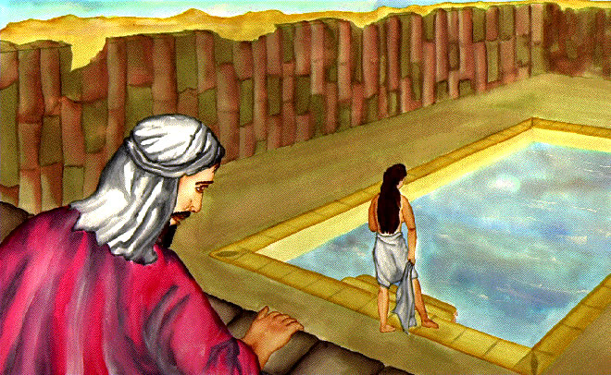

20
1.

James 1v. 12-15
The Three Phases of Sin Manifestation:
- Mental: a mind is engaged
- Moral: a breach is hatched
- Physical: that breach is acted upon resulting in a sin, consequences and, or death.

TEN CONTRIBUTING FACTORS TO DAVIDS DOWNFALL:
1.PROCRASTINATION
2.LOCATION
3.LAZINESS
4.IMMODESTY
5.CONTROL OF EYES
6. CONTROL OF THOUGHTS
7. DISRESPECT
8. COMPANIONS
9. VALUES
10. DISLOYALTY
3.

22

THE REALITY OF UNCHECKED SIN BECOMES HARDER TO CONCEAL !

4.

THE COVER-UP
“When we have sinned in a high profile manner, we are more eager to conceal it before men than to confess it before God.”
David tried two schemes to cover things up:
1.He did his best to encourage Uriah to lie with Bathsheba. II Sam. 11v.8
2. When that failed, he decided to marry Bathsheba and to engineer the death of Uriah.

pause

POINT: Those who are principled and live Godly lives will always be the target of those who do not. Godly conduct upsets those who are relaxed; other Christians will call us too strict, straight-laced, extremists, puritanical or maybe even Thomasites.
POINT: When we are in the throws of sin and resisting it or contending against it, understand that it might be an uncomfortable and drawn-out situation that requires great personal effort and resolve.

PLAN B…Kill Uriah
David is maneuvering totally on his own.
His Heart is seared, his prayers have dried up; Yahweh has pulled back.
II Sam. 11v.15: “And he wrote in the letter, saying Set ye Uriah in the forefront of the hottest battle, and retire from him that he may be smitten and die.”
II Sam. 11v.25: …”Thus shalt thou say unto Joab, Let not this thing displease thee, for the sword devoureth one as well as another.”
(it is what it is…so get over it!)

This treachery was David’s lowest point in his life.

With the Pregnancy Came The Perfect Medium to Teach The Process of Sin
Three Major Stages:
- The consequences begin immediately
- The growing in size of the Sin increases with time
- The uncovering and showing of Sin

YAHWEH IS NOT MOCKED !

DAVID’S PSHCHE HAD SHELTERED HIM THUS FAR: “The heart of man is deceitful above all else, who can know it?”
An outside source is helpful in seeing our own sins/faults. The WORD OF GOD is always the most reliable.

“Blessed is the man who has an active conscience.” …John S. Peake

FORGIVENESS IS ANOTHER 3 STEP PROCESS
(a parallel to the process of sin in James 1v. 14)

Step One is Mental: The sinner must realize and confess that he has sinned.
Step Two is Moral: The sinner must exercise himself, come to grips with it and ASK GOD FOR FORGIVENESS.
Step Three is Physical: Repentance must follow a resolve to “go and sin no more.”
Psalm 86v.5: “For thou Lord art good, and ready to forgive and plenteous in mercy unto all those who call upon thee.”

Psalm 51: David’s heartfelt prayer seeking forgiveness. “I acknowledge my transgressions, and my sin is ever before me”

Psalm 32: This is the conclusion of Psalm 51 in that David’s prayer for forgiveness is granted him.

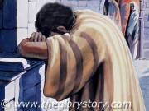

“Blessed is he whose transgression is forgiven, whose sin is covered.”

Forgiveness: #5545-5547 (to forgive, pardon,
to spare
Remission: #859 (freedom, pardon,
forgiveness, liberty)
Repentance: #5162-5164 (to be sorry, to
breath strongly, to repent)
Mercy: #26170 (kindliness, good deeds)
Grace: #2580 O.T. (kindness, favor, precious,
well favored)
#N.T. 5485(benefit, gift, favor, pleasure)

A Closer Look At Grace
“Prevenient Grace” A Christian concept that God’s Grace preceeds belief, & repentance.
False Premises:We are saved by Grace alone
- Commitment or life style changes are not necessary to be justified by God.
- Faith in Jesus (not repentance) is the sole condition for justification and eternal life; turning from sins is not a prerequisite or a requirement to salvation.
- Obedience is not necessary for salvation.

ACTS 2V.37-38 : OUR MODEL
“…when they heard, they were 1pricked in their hearts and asked Peter, ”what shall we do?” Peter said 2repent and be 3baptized…in the name of Jesus Christ for the remission of sins…”

Mental(heart pricked) Moral( repentance)
Physical Action (baptized).

God’s Grace is predicated upon our initiative…the model is in Covenant

A QUOTE FROM AN EVANGELICAL MINISTER
“Obedience to God is simply something we do in response to His forgiveness, as a sense of gratitude…but only if we want to. It is not required of us for salvation, it is merely something nice we do if we want to show we love Him.”

THUS THE FALSE DOCTRINE OF:
Once Saved Always Saved

END STUDIES ON DAVID & BATHSHEBA

BLANK

DAVID’S INHERENT KINDNESS
II SAMUEL CHAP. 9

A MAN AFTER GOD’S OWN HEART

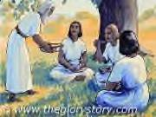

1.

“WINDOWS OF BLESSING” FOR A
RIGHTEOUS ONES SAKE

II Samuel 9v.1:“And David said, Is there yet any who is left of the house of Saul, that I may show him kindness for Jonathan’s sake?”
Ephesians 4 v.32: “… be you kind one to another,…forgiving one another, even as God, for Christ’s sake, hath forgiven you.”
James 5v.16: “The effectual fervent prayer of a righteous man availeth much.”
2.

KINDNESS: “THE FULL FLOW OF NATURAL AFFECTION…LEXICON ADDS “THE GRACE, FAVOR, & MERCY OF GOD TOWARDS MEN.”

David understood this and wanted to share this “Kindness” with any of the house of Saul.

His was a position of righteous authority, as is Christ now.
3.

3.

3.

MEPHIBOSHETH LIVED IN OBSCURITY IN LODEBAR IN GILEAD: rendered as “pasture-less or a place of desolation.”
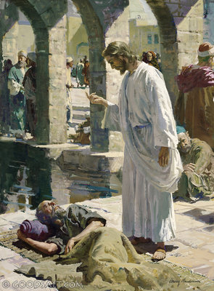

4.

“David said, Mephibosheth, and he answered, Behold, thy servant.”
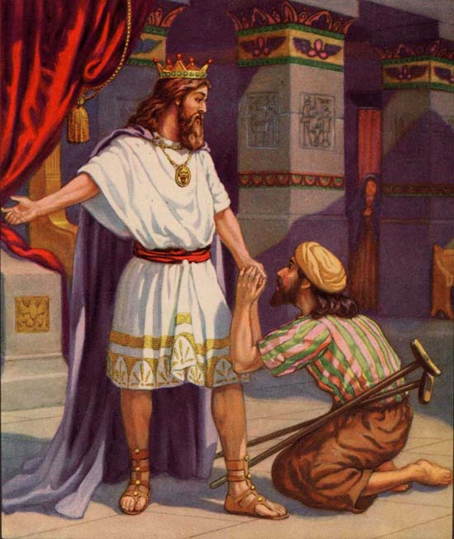
5.

II SAMUEL 9v.7
“FEAR NOT, for I will surely show thee kindness for Jonathan thy father’s sake, and will restore thee all the land of Saul, thy father, and thou shalt eat at my table continually.”

Revelation 19 v.9
…”Blessed are they who are called unto the marriage supper of the lamb.”
6.

6.

“Thou preparest a table before me…thou anointest my head with oil; my cup runneth over; surely goodness and mercy shall follow me all the days of my life; and I will dwell in the house of the Lord forever.” After the type of Mephibosheth
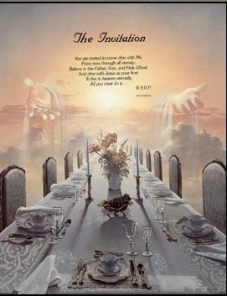

7.

7

END DAVID’S

DEMONSTRATION OF

HEARTFELT KINDNESS

blank

THE VENGEANCE OF THE GIBEONITES

II SAMUEL 21 & Joshua 9

A Lesson on Covenant Keeping
And Swearing

1.

JOSHUA AND THE PRINCES OF ISRAEL SUFFER A LAPSE IN FOCUS OF GOD’S WILL
AND PURPOSE …JOSH. 9V.15

LIES, STEALTH, FLATTERY and “seducing spirits” HAVE DELUDED LEADERS AND NATIONS FOR AGES …including ISRAEL.
Consider: Eve and the Serpent; Jacob & Esau; Samson & Delilah; the Jezebels; the Gibeonites; “The Man of Sin”; Gog…and the United Nations in Totality, to name a few. 2.

Jezebel

The Gibeonites had studied about Israel, her God Yahweh and the ramifications of covenant but they had a self-serving agenda as do some today.

II Tim. 3v.5: “Having a form of godliness, but denying the power of it; from such turn away.”

UNCHECKED SIN CAUSES MUCH GRIEF AND HEART ACHE
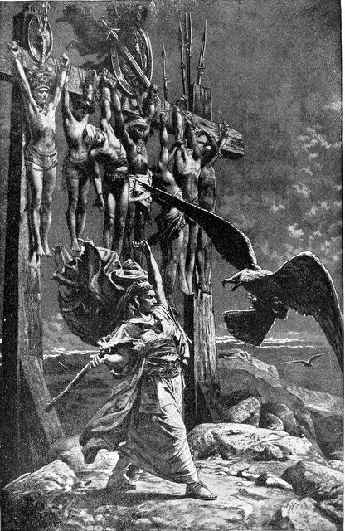
RIZPAH…A Type of Innocent casualty

END SECTION ON GIBEONITE VENGENCE
AND THE RAMIFICATIONS OF COVENANT
KEEPING…OR BREAKING.

BLANK

DAVID’S END GAME, ACCOMPLISHMENTS,
AND FINAL TESTS

ABSALOM…An arrogant and spoiled worshipper of himself
He despised his father David with little regard for his God, Yahweh.
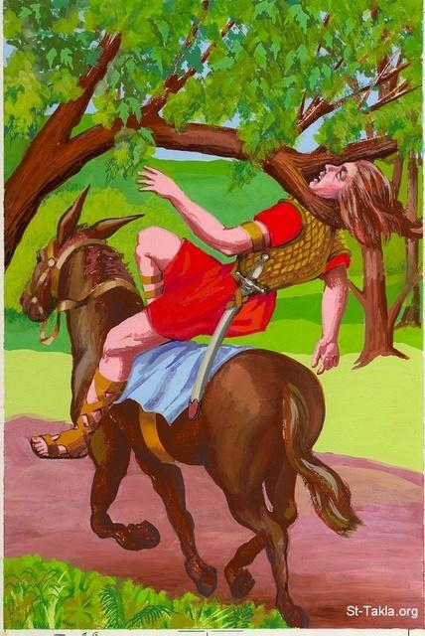

ENSNARED BY HIS OWN ENTANGLEMENT
ABA

ABSOLOM CAUGHT IN HIS OWN ENTANGLEMENT
SIX IS THE NUMBER OF MAN, DESTITUTE OF GOD AND of IMPERFECTION IN GENERAL.
Ephesians 6v.12: “For we wrestle not against flesh and blood, but against principalities, against powers, against the rulers of the darkness of this world, against spiritual wickedness in high places.”
THE SAME AS: Daniel’s Image; Daniel’s 4th Beast; The “Great Mountain” before Zerubbabel; The Vine of the Earth; The woman on the Scarlet-colored Beast; Babylon, Egypt and Sodom.

A pause

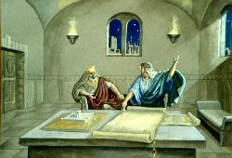
I CHRONICLES 28V. 19: “…said David, “THE LORD MADE ME UNDERSTAND IN WRITING BY HIS HAND UPON ME, EVEN ALL THE WORKS OF THIS PATTERN” 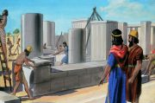

I KINGS 1V1: “NOW KING DAVID WAS OLD AND STRICKEN IN YEARS; AND THEY COVERED HIM WITH CLOTHES BUT HE “GAT NO HEAT.”
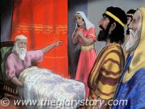

David revived, rose from his bed and met the challenge of Adonijah’s usurpation.

I CHRONICLES 9V.22: suggests that Samuel had mentored David, counseling him in reorganizing the various orders of servants.

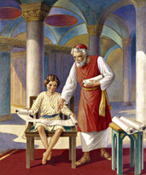

“Well done thou good and faithful servants, be thou over”… cities, countries, municipalities, institutions, Temple activities, education, law enforcement, the poor, medical and disease control, agriculture, energy, pollution, sacrificial animals, centers of learning, administrators at every level, hydrologists, etc. But there will be no lawyers or Cannaanites or any that “worketh a lie.”
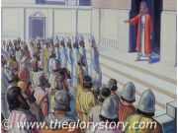

I KINGS 2 5-7 DAVID CHARGED SOLOMON ABOUT
Necessary “housekeeping” suggestions:
JOAB: a treacherous opportunist
SHIMEI: a deceitful and cowardly “friend”
ADONIJAH:an ambitious political schemer
The reaping of the sickles against “the clusters” of the adversaries as in Rev. 14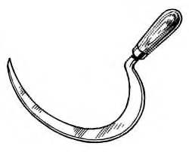

In I Kings 2v.1-4: NOW REGARDING SOLOMON:
Verse 2…”BE STRONG AND SHOW THYSELF A MAN”
THREE ASPECTS: 1. Be a masculine leader
2. Be strong mentally
3. Be strong spiritually
Verse 3…”Keep the charge of the Lord , to walk in His ways to keep his statutes, and His commandments, and His ordinances, and His testimonies …that thou mayest prosper.”
EXCERPTS FROM II SAMUEL 22…DAVID’S SONG
v.2 “…the Lord is my rock, and my fortress, and my deliverer.”
v.7 “In my distress I called upon the Lord…and He did hear my voice…my cry did enter into His ears.”
v.29 “For thou art my lamp, O Lord…”
v.33”God is my strength and power, and He maketh my way perfect.”

EEe

End classes on David…

“The Man After God’s Own Heart”

Ark. Bible School 6/2012
Bro. Don Northey

